Home

Welcome to the TFleet user manual. Hover over the left side of the screen to reveal the table of contents or use the search bar.

Install

The application should be installed in a directory not covered by OneDrive, as some users have reported problems in the past that were due to this. C:/ should be a safe directory to drop the application folder. Users can, however, create shortcuts to the .exe and place them wherever they prefer for commodity.

Bug report

You may have an email address to report bugs and problems. When doing so, it is essential that you provide a description and sufficient means that allow the developer team to reproduce your situation. This should be, at least, a description of the problem, how did you reach it, and an associated .cfg or .FSSolved file related to the problem (or both, or .xlsx files, or whatever is related). If providing such a file is not possible, try to be very clear in your definition of the problem and how/when did it trigger, and the steps taken to reach the situation. Do not hesitate to attach screenshots if they can help understand the problem.

Main menu

The main menu gives you access to the different windows and functionalities of the application. A little rectangle in the bottom left corner displays information about your license.
In the bottom you can find buttons to define and run an optimisation scenario. They are explained on their respective sections, accessible through the left index pannel.

Optimise buttons

In the bottom, there are two buttons to run the optimisation engine
- Single run: Runs the optimisation to produce a 7-days output, with up to one maintenance per train. Note that maintenance km limit constraints are ignored after the maintenance is done, and this could lead to a schedule where the last day trains have kilometre counters that are not valid. This mode is however useful for obtaining solutions one by one that can be later combined into a single schedule. The "Log steps" and "Solutions per log" under the application settings modify the number of solutions randomly generated. The more solutions, the more chances to obtain a better solution and more elapsed time.
- Multiple runs: Runs the optimisation as many times as the setting "Number of cuts” and takes as many days as stated in "Days per cut" from each solution, allowing to bypass the optimisation limit of maximum one maintenance per train and schedule. This also means that schedules longer than 7 days can be generated. Note that each of the "runs" is a "single run", with each relying on its associated settings. If a train receives more than one maintenance, second and subsequent maintenances are defined by the "Default intervention" parameters under the general settings in the application settings. Reference to all the aforementioned settings here.

Other functions

The left side contains buttons that allow the user to access other features, explained below:
 | Opens the settings windows. This has a separate section where the different settings are explained. They affect the visuals of the application, the optimisation algorithm, and some utilities of the scheduling dashboard. |  | Opens the manual. It can also be accessed pressing F1.
 | Allows to save the scenario in a .cfg file, so it can be transferred or opened later. This saves the stations, fleet, services, maintenance transfers and overnight transfers. Optionally, the user can get a confirmation setting when loading or saving this files; this is configurable in the general settings. |  | Similar to the save button, it loads a .cfg file. Optionally, the user can get a confirmation setting when loading or saving this files; this is configurable in the general settings.
 | This allows the user to open a previously saved schedule. Schedules can be saved when they are opened, with one of the buttons in their toolbar. |  | This button allows the user to combine several schedules that have been saved as FSSolved. The user can select several files, one by one, and they will be loaded from their initial day to the day picked in the prompts. The trains in the different files should match, and the user should make sure that the days manually picked as end of each file match as a starting day in the next file to be picked. Clicking "cancel" in any of the windows will halt the process.
Missing Icon | Opens the library menu, where the user can define different schedule elements to summon them faster when editing schedules.

Define stations

The first step to build our optimisation scenario is defining the stations which the fleet will travel to. It is worth noting that for a train to access or leave a station, a service is required. In some cases, there might be several stations that are interchangeable due to their vicinity; in these cases, using a single station to represent all of them might be beneficial - this is, in the cases where a given service utilises either one station or the other indiscriminately. Filling the stations is necessary to access other windows, such as fleet and service definition.
Each row represents one station, and more rows can be added with the Add row button in the top. Three fields are to be filled in order to define a station, and rows can be eliminated with the basket button on the right side.
- The station name, used to reference it in the rest of instances of the application. Any character string containing “depot”, “maintenance” or “overnight” are strictly forbidden, no matter the combination of capital letters used.
- A two letters identifier for the station, that must be unique and will be displayed when the results are exported to excel
- A checkbox to indicate whether a station includes a maintenance depot or not. If the box is checked, two fictional nodes will be created with the suffixes "-Depot (maintenance)" and "-Depot (overnight)" that will allocate trains undergoing maintenance operations and trains that stay idle during the night in the depot, respectively.

Define fleet

Here we will define the state of the fleet at the initial moment of the optimisation. This includes defining the trains, their location, their current kilometres and the maximum they can travel before undergoing maintenance. Some other constraints can be defined too, such as an initial unavailability of the train or forcing it to start with a specific service.

Fleet definition

Each row represents one train, and more rows can be added with the Add row button in the top. Several fields are to be filled in order to define a train, being some of them optional, and rows can be eliminated with the basket button on the right side.
- Train ID is a compulsory field indicating the identifier of the train. After saving and leaving the window, all rows will be sorted based on this, and they will follow this sort in the schedule.
- Initial degradation refers to the kilometres counter the train has now. This influences when maintenance is going to be carried out and can also be defined as the number of kilometres ran since the last maintenance intervention.
- Maint. km limit indicates the max km counter value before a train does maintenance. The number of kilometres available to be done is the difference between the value in this field and in the initial degradation field.
- Next maint. name refers to the name of the next maintenance intervention, that will be displayed on top of it in the schedule.
- Next maint. duration indicates how much time will the train be blocked by its next maintenance operation. This does not include time to transition to and from depot if this is necessary.
- Location indicates where the train is at the beginning of the schedule.
- Location info is an optional field, that will display additional information in the initial box of the corresponding train within the schedule.
- Availability start-time is an optional field that will block the train for the inputted amount of hours. If left empty, a compulsory value of 0.1 is automatically considered.
- Forced service (optional) forces the train to do a specific service as its first service. The Service ID has to be indicated within the field for this, and if several services share the same id (because of existing in several days, for example) the most immediate one is selected.
- Bans (optional) allow the user to input one or several services separated by commas that cannot be done straight after the initial service. This will refer to all services with such service ID.
- Colour, used when displaying the initial box

Import from SAP

It is possible to import some of the fields from a .xlsx file generated from SAP. The fields that can be imported are the Train ID, the initial degradation, the name of the next maintenance intervention and the maintenance km limit. As for now, this function will look for columns with the following headers (non-case-sensitive), being all of them needed for the function to work:
- "Composición", indicating the Train ID.
- "Val Desde Int.", indicating how many km have passed since the last intervention.
- "Interv.", indicating the name of the intervention.
- "Margen Max." indicating the max number of kilometres that can be done before the maintenance intervention.
- "U.M." any row that does not have the value "KM" under this column will be discarded.
When importing, it is worth noting some rules about deciding which will be the next maintenance intervention. If the most frequent intervention has a frequency of for example, 8000 km and only 1000 km are left for it to be done, but there is a higher-tier intervention for which remaining kilometres are higher than 1000 but lower than the highest of the frequencies (for example, there are only 4000 km remaining for such intervention) then the next maintenance will be in 1000 km at most, but this maintenance will be the one with the higher tier previously mentioned.

Define services

Services are the general element of a schedule. Anything defined as a service will be considered as compulsory and will be allocated to a train in the schedule. If this is not possible, then the solution will be considered infeasible.
Each row represents one service, that can be done once or repeated several days, and more rows can be added with the Add row button in the top. Several fields are to be filled in order to define a service, being some of them optional, and rows can be eliminated with the basket button on the right side.
As one can notice, there is an extra field in the top. This dropdown list is used to select the starting day of the simulation; this is, indicating which day does the hour zero correspond to. The user can select "current" so the day is automatically selected base on the system's date. Please consider that the starting day, set of defined services and initial status of the fleet must match so a solution is feasible.
- Service ID defines an identifier for the service, displayed on top of the schedule boxes. It's also utilised to refer to the service in other fields, such as forced service or bans.
- From and To are used to indicate the origin and destination of the services. The special, fictional nodes that represent the depot are not accessible here.
- The number of kilometres that the service does, contributing to narrowing the margin for maintenance.
- Departure and Arrival times, in the format HH:MM. If one services finishes a different day than the day it started, the little box next to the arrival time needs to be used. This box expects an integer number; each value will add 24 hours to the arrival time of the service. Leaving the extra field empty is the same a writing 0 on it
- Forced service (optional) forces the train to do a specific service after doing the one represented by the row. The Service ID has to be indicated within the field for this, and if several services share the same id (because of existing in several days, for example) the most immediate one is selected.
- Bans (optional) allow the user to input one or several services separated by commas that cannot be done straight after doing the one represented by the row. This will refer to all services with such service ID.
- The input fields representing different days of the week are used to indicate how many times a service is done each day. This can be any integer number, greater or equal than zero. The fields can be left empty, being this treated as a 0. Leaving the fields empty when there are no services that day is encouraged for the sake of visibility.
- A colour, used when displaying the schedule boxes.

Define depot transfers for maintenance

When defining the nodes we mentioned that ticking the depot field for a station would create fictional nodes by adding a suffix to the station name. Now we will address the stations named as "<station>-Depot (maintenance)". This is where maintenance operations are executed and are only accessible through a transfer between the depot and the civil station. In cases where this transfer is not necessary, you still have to do it conceptually but can make it infinitely small (like a single-minute transfer with zero kilometres). Depot transfers are also utilised to indicate the capacity of the depot.
A row will be automatically created for each station ticked as a depot in the station's definition window, with a label displaying the corresponding station; rows cannot be added or deleted. Each of the rows can have one or more subrows (one by default, they can be added or deleted using the +/- icons on the right side). This will be explained later in this section. The elements to define depot transfers are:
- Transfer IDs, indicated on the schedule box displayed on the schedule. You can have either the same or different IDs when going to and from the depot.
- Duration of the transfer, in minutes
- Kilometres of the transfer
- Definition of capacity: This is achieved using the "Gap start time" field, the weekly fields, and the subrows feature. This allows the user to create time ranges and define the working capacity of those. The system works the following way:
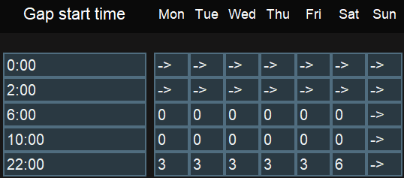
  - There is one gap start time per subrow. The one in the top must be 0:00 and cannot be edited (start of the day) and the consecutive ones can range from 0:01 to 23:59. The gap start time indicates when the capacity defined in the subrow starts, and it will last until the next gap start time (when there is a single subrow, it is assumed that the time range spans the whole day).
  - The weekly entry fields are used to define the capacity of that specific time gap. This is, how many trains can gain access to the depot within that time gap (which is not the same as the trains in the depot at that same time). The values expected are integer numbers equal or greater than zero or "->", as a special feature.
  - The very first input at each row consists on a menu with the location of the depot by default. However, the menu will allow the user to choose other options in the form of “Current Depot > Another existing Depot”. When one of these options is selected, “Current Depot” will use the capacity of “Another existing Depot”, with this capacity being shared.
A way to easily read the example in the right would be the following: Let's read from the top-left corner, from top to bottom and then from left to right. Following this direction, let's find the first number other than zero (Monday - 22:00). We can see that starting at 22:00, a time gap for up to three trains starts. 22:00 is the last row, therefore this gap would initially last until Monday - 23:59. However, the next cell (Tuesday - 0:00) contains the special characters "->". This means that the previous gap is extended, effectively merging Monday - 22:00-23:59 and Tuesday - 0:00-1:59 into a single gap. The next cell contains again the special characters "->", so the gap is actually from Monday - 22:00 to Tuesday - 5:59. This means that within this margin, up to three trains can enter maintenance. The user can continue reading/filling the matrix this way, until they reach the starting cell again and therefore close the loop.
- A colour for the transfer schedule box can be picked as usual

Define depot idle overnight trains

Whenever there is a depot, trains can stay overnight in the fictional separate station. How many of them can stay each night, access limitations and the transfer to the depot are defined in this screen. Many of the elements are very similar to the ones in depot transfers.
A row will be automatically created for each station marked as a depot, and a label will display the corresponding station. The elements to be defined in this screen are
- Transfer IDs, indicated on the schedule box displayed on the schedule. You can have either the same or different IDs when going to and from the depot.
- Duration of the transfer, in minutes
- Kilometres of the transfer
- The late-night transfer time limit defines the cut-off time after which trains with services ending beyond this limit will not be sent to spend the night in the depot
- The early morning transfer time limit prevents trains that need to start service earlier than this time to be sent to spend the night in the depot
- The weekly days cells will define the number of trains that can be sent to sleep each day of the week, if the conditions are met. If it is possible to have a trains sleeping in the depot than in the "civil" station, this will be enforced. A train receiving maintenance will also occupy a sleeping space; this capacity is a soft restriction, implying that if the maintenance capacity is higher than the overnight capacity, then the maintenance capacity wins but no trains will be sent to sleep that night. When calculating the available capacity for sleeping in the depot, the formula is available capacity = capacity - used maintenance capacity, In other words, maintenance is always priority.
- A colour for the transfer schedule box can be picked as usual

Application settings

The user can define here several settings related to different areas of the application

General settings

- Language: Allows the user to change the language of the application.
- App colour: Changes the theme of the application, except for the schedule dashboard.
- Confirmation pop-up when loading or saving .cfg files: Enables a pop-up that indicates that a .cfg file has been loaded/saved.
- Minimum required idle time between services (minutes): Defines the minimum time between services so a service can be considered as a successor of another service. This affects the feasibility of solutions. Forced services ignore this restriction.
- Default intervention name: defines the name for interventions that are done of trains when they have received maintenance at least one time when using the "Multiple runs" optimisation
- Default intervention km: defines the km limit for interventions that are done of trains when they have received maintenance at least one time when using the "Multiple runs" optimisation
- Default intervention duration: defines the duration (hours) for interventions that are done of trains when they have received maintenance at least one time when using the "Multiple runs" optimisation

Graphic solution settings

- Display colour: Changes the theme of the schedule dashboard
- Maintenance color: defines the color that will be given to maintenance schedule boxes.
- Extra rows: Adds empty rows on top of the schedule, intended to assist the process of manually dragging boxes. Minimum value is 1
- Export maintenance duration to excel: Displays the length of maintenance in Excel cells that relate to a maintenance

Heuristic parameters (advanced)

- Log steps: Defines how many times a log output is produced per single run.
- Solutions per log: Defines how many solutions are generated before each log output. The total number of solutions generated in a single run is the product of this and the previous setting.
- Ignore stepping limitations when no solution is found: If no feasible solutions are found and the limit of generated solutions is reached, the engine will continue generating solutions until one feasible is found.
- Maintenance avoidance margin: If the difference between the kilometres done by a train and its kilometres limit is higher than this, the train will not try to do maintenance.
- Maintenance critical margin: If the difference between the kilometres done by a train and its kilometres limit is higher than this and lower to the previous setting, the train will try to do maintenance, but the solution will still be considered as feasible if this is not possible. If the difference is lower than this setting's value, the train must be able to do maintenance for the solution to be considered feasible.
- Tolerance to link transfers and maintenances (minutes): Deprecated. Will be removed.

Multicutting parameters

- Number of cuts: When running the optimiser through the "multiple runs" button, defines how many individual solutions are going to be merged.
- Days per cut: When running the optimiser through the "multiple runs" button, defines how many days are picker per individual solution.

Optimisation

This section explains the optimisation algorithm and its features.

Optimisation algorithm

The optimiser works by generating random solutions, analysing their feasibility, and picking the best solution - this is, the solution that yields a higher kilometres count prior to any maintenance. The optimisation is a CPU-intensive process; this means, that your CPU is the main actor able to give you a better speed. Computer settings also affect your optimisation speed, in the way that they are applied on your CPU. It is strongly suggested to run the optimisation with any energy saving feature deactivated and with the power cable connected if using a laptop.
When running the optimiser through the single run option, a button allows the user to halt the process when the next log entry shows up; Similarly, a button shows up when the process is finished allowing the user to perform more runs to try to obtain a better result. When running using the "Multiple runs" button, the process cannot be halted (unless closing the log window, which equals to cancelling it) and the result will be shown directly.

Optimiser log

The log offers information to the user about the current state of the optimisation. There are slight differences between the log displayed in the Single run mode and the Multiple runs mode. However, the essential information is conveyed in the same way for both cases. The log will always display information each time a "step" is completed. A step refers to the generation and evaluation of a certain number of solutions. In the single run mode, when all the steps are done the process will finish. If running the multiple runs mode, a cut is completed when all the steps are completed, and the simulation finishes when all the cuts are done. Solutions per steps, steps, and cuts are configurable in settings.
This log can offer information about the problems that the algorithm is finding when trying to obtain better solutions. Infeasibility refers to solutions that have been generated but are not valid, because of any reason. The best solution value is indicative for how good a solution is. This is related to the number of kilometres done by trains before their maintenance, hence the higher the better. Please, consider though that values will then depend on the number of trains, the length (in days) of the simulation horizon and the maximum kilometres before maintenance; consider that a solution of for example "30000" can be very good for one scenario and very bad for another one, so this value should be only compared to other values of the same scenario, to understand the evolution of the algorithm. When running the Multiple runs mode, the best value is reset to "-infinite" after each cut is accomplished.
There can be different reasons for a solution to be infeasible; sometimes, it can be a cause of user errors, but it can also be a normal part of the process. In general, it would be strange to find a scenario for which all generated solutions are feasible. In the other hand, if we see a scenario where 100% or the solutions are infeasible, one should consider looking the settings and checking if everything is defined properly.
It is very difficult to specifically address the cause of infeasibility for a given solution. In many cases, there might be more than one, and it may even be the case where not all of them need to be solved for a solution to become feasible. This makes almost impossible to say why a solution is infeasible. The very few cases that can be specifically targeted are prompted to the user before the optimisation process starts. However, the log will still categorise the infeasible solutions depending on which task was the algorithm performing when the solution was identified as not valid. In the following list we will explain these categories and refer with "process" to the generation and evaluation of a single solution.
- Infeasible (A): These means that the process was halted when generating the solution because a service could not be assigned to any of the trains. Although theoretically having valid predecessor services, which is checked at the beginning of the optimisation, none of the latest services done by the trains prior to this is one of them. In some cases, one can see that a certain number of solutions falls under this category, but not all; this is not necessarily a problem and is usually related to the use of the "bans" constraint. However, if 100% of the solutions fall under this category one should check the fleet and services definition.
- Infeasible (B): These means that a train has fallen under the "maintenance must be done" category (according to the avoidance and critical margins defined in settings), has reached a depot at least one time, but none of the times it has reached a depot has it been able to do maintenance, either due to excessive time compared to the available time or capacity constraints. If it becomes necessary to analyse why solutions fall into this category, one can start by making maintenance stops infinitely short and looking how the schedule looks. Should I prevent (ban) some services after some specific ones? Should I force other services? Am I overloading the trains because I forgot to include a train?...
- Infeasible (C): These means that a train has fallen under the "maintenance must be done" category (according to the avoidance and critical margins defined in settings) and has not been able to reach a depot. In order to generate a full schedule for debugging purposes we can infinitely increase the km limit before maintenance of trains. One can be interested in seeing a debugging schedule to check if services are distributed in a strange way and ask proper questions such as "Am I missing some services? Should I force some services? Should I ban some services after other specific ones, especially if the to-be-banned ones start a long-lasting chain if services without valid maintenance windows?"

Schedule Display

This section will display the schedule window, reachable through the calculation of a new solution or the load of an existing one. A calculated solution before any manual alterations consists in the schedule of services and maintenance operations, alongside their transfers to and from depots, considering capacity and overnight constraints as well service-chains.
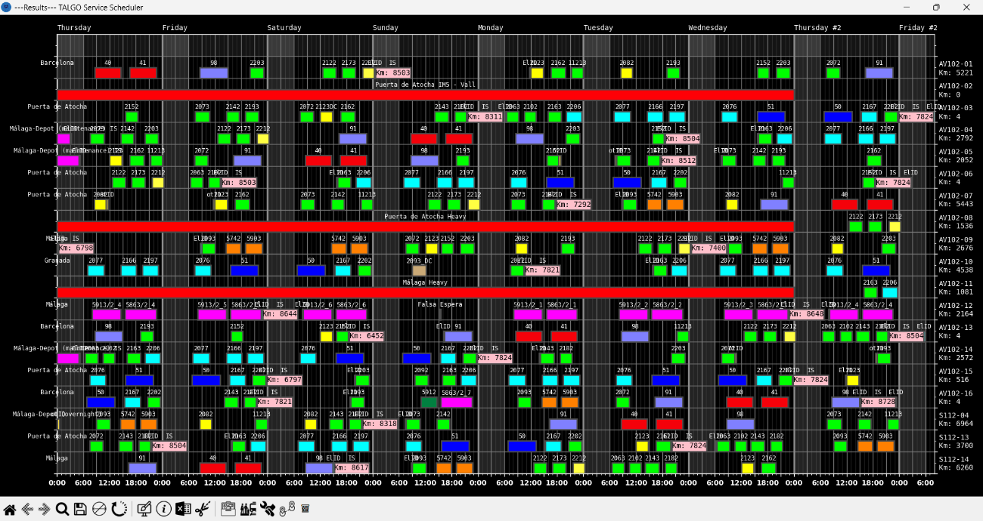

Side & background info

The X-axis relates to the time, in hours; weekdays can be seen in the top. Y-axis represents the trains, being each row a train; in the right, their identifiers can be seen alongside the distance travelled since their last intervention. A greyed vertical line is displayed to indicate the different hours of the day, with thicker lines each three hours. From 0:00 to 6:00, the dashboard uses a different background to clearly indicate the period, usually relevant for maintenance operations. Information about where the cursor is pointing can be seen in the bottom right corner of the screen.

Toolbar

The toolbar is an essential element of the display. It contains buttons that allow the user to perform different actions, ranging from modifications to exporting the results, as well as other utilities.
- Ban horizontal movement. This button toggles an option when clicked that prevents boxes from moving horizontally. This is relevant for maintenance boxes, as those are the only ones that can move sideways. This feature can also be enabled by holding "H" while left clicking on the box or just by using the middle mouse button to click on the box.
- Undo button (Ctrl + Z). Undoes last action performed on the schedule.
- Redo button (Ctrl + R). Redoes what has just been undone.
- Restart button (Ctrl + Alt + R). Resets the schedule to its initial state by running the undo command as many times as possible.
- Save solution (Ctrl + S). Saves solution in a FSsolved file, so work can be resumed later through the main menu. This custom file format works as a JSON file and can be edited manually with a text editor, but it is not recommended as there is a high corruption risk for users unfamiliar with the format.
- Excel format button (Ctrl + E). Exports the schedule to an .xlsx file, which at the same time is ready to be exported to a .pdf for external distribution or other purposes.
- Generate daily cut (Ctrl + K). Open a menu prompting the user to choose a day; the initial definition of the fleet will be reconfigured to match with the state of the fleet of that given day, and automatically changed in the application. A pop-up will allow the user to define the predefined maintenance (defined in the application settings) as the next maintenance for those trains that already underwent maintenance. The user will be later prompted to save it as a .cfg file if they wish.
- Locations summary (Ctrl + L). When selected, click somewhere in the schedule and a pop-up will inform the user of the trains’ locations at the beginning and end of the clicked day.
- Library button (Ctrl + N). Opens the library
- Create new service (Ctrl + Q). Opens the dialog box for creating a new service.
- Create new maintenance (Ctrl + A). Opens the dialog box for creating a new maintenance.
- Create new transfer (Ctrl + T). Opens the dialog box for creating a new transfer.

Schedule boxes

Boxes are the most distinguishable element of the schedule. In the schedule, they are used to represent timespans with active services, maintenance operations, and transfer to or from depots. Idle times are represented with just an empty space, but the user may position other boxes in those spaces to provide information if desired, for example, to indicate that a train is set as a reserve train or undergoing operations such as cleaning.
A solution can be reached directly by running the optimisation algorithm for a given scenario or accessing a previously saved schedule. Then, boxes can be added manually or the current ones can be moved by clicking and dragging them; their movements are delimited by their category, and will be explained later
The schedule will automatically give visual feedback to the user indicating if some scheduling constraints are being violated. They will be represented by drawing a certain line pattern on affected boxes. These can be seen in the following list:
- A diagonal hash pattern on a box indicates that the service is not being originated at the location of the train, known from the destination of the latest service prior to that. This same pattern can be seen in maintenance boxes when they exceed the km limit.
- 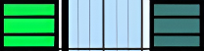If a horizontal hash pattern is shown, it means that the service in the left requires a specific service to be done after it, but the one in the right is not the expected one. The desired service is defined by its identifier
- An X-shaped hash pattern indicates that the service in the left requires that certain services are not done straight after it, but the one in the right is one of such forbidden set. The banned services are defined by their identifiers
- 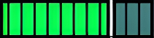A vertical hash pattern indicates that the time between two services is minor than a desired minimum gap between services, defined in the general settings of the application. This constraint can be overridden by the optimiser if the services are forced with the "conditioned" constraint when defined, with the optimiser effectively placing them consecutively (but the pattern will still be displayed)
The constraints display follows the order of the list; this means that if constraints 1 and 3 are being violated, the displayed pattern will be the one of constraint 1. Each time the schedule is altered, constraints are revisited, and all the kilometre counters are automatically updated
Empty rows can be added to the top of the schedule; they can be used to ease the movement and switching of boxes to the user. The number of lines added on top can be modified on the application settings menu
Interaction with the boxes of the schedule is possible. Holding left click over any of the boxes allows the user to move them. For boxes that allow horizontal movement, displacements along the X-axis can be avoided by combining "H" key and left click, by simply using the middle mouse button, or by triggering the "Ban horizontal movement" option . Holding Backspace or Supr. while left-clicking a box will delete the box; left-clicking a box while the deletion tool (marked by a bin) is active will cause the same effect. Right clicking a box will open the properties window of that box, which is the same as a creation window for a box of that category with the data of the selected box already entered

Service boxes
Service boxes are mainly used to represent services but can be also used to show a specific state of the train during a given period. Services can only be dragged vertically. A service is defined by the following elements:
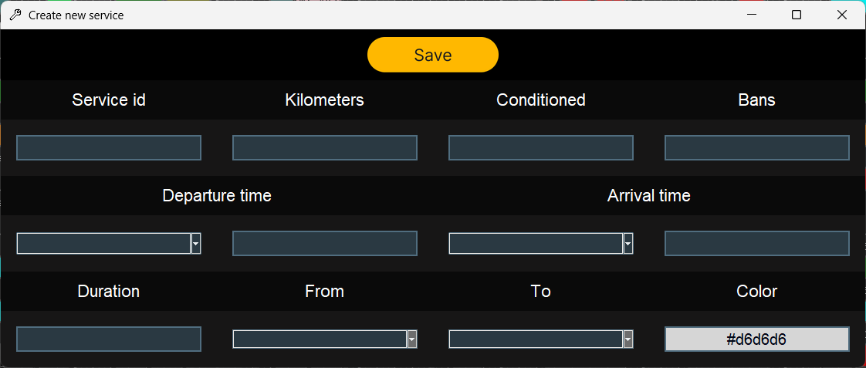
- A service identifier, relevant for constraints such as #2 and #3.
- A number of kilometres, relevant for constraint #1. The user can input "0" to create a service like "Reserve period", and graphically indicate that a train is just idle on reserve during a set time.
- An optional field to indicate whether the service forces the train to do a specific one after it. This is done by indicating the service identifier of such service.
- An optional field to indicate whether the service forbids the train from doing a set of services straight after this one. This is done by indicating the service identifiers of such services, separated by commas when more than one.
- Departure time and arrival time, consisting each in one field indicating the day and another one for the time.
- Duration, in hours, of the service. If departure and arrival times are specified, this field is completed automatically. Retroactively, if a pair of the previous fields is specified and this one, the unspecified one will be automatically filled.
- Two fields indicating the origin and destination of the service.
- The colour which will be represented to display the box

Transfer boxes
Transfer boxes represent special services that allow the trains to reach a depot. Transfers can be to or from a depot and can be dragged both vertically and horizontally. The elements defining a transfer are:
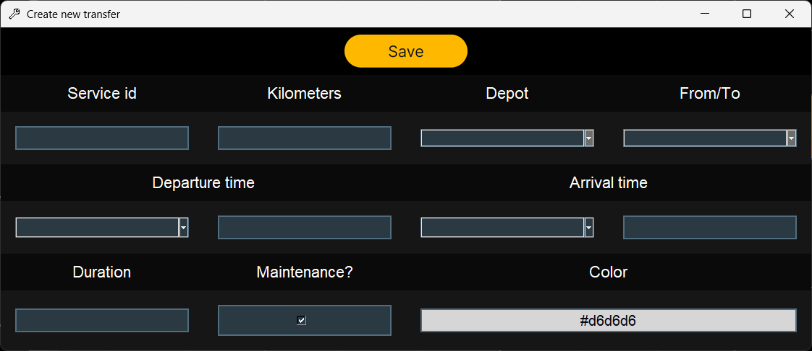
- A service identifier, that will be displayed on top of the box.
- A number of kilometres.
- The depot to which the transfer service is related.
- A dropdown, to indicate if the transfer is from the "service" station to the "depot" station or viceversa.
- Departure time and arrival time, consisting each in one field indicating the day and another one for the time.
- Duration, in hours, of the service. If departure and arrival times are specified, this field is completed automatically. Retroactively, if a pair of the previous fields is specified and this one, the unspecified one will be automatically filled.
- A chechkbox, used to indicate if the transfer relates to the maintenance-related station or the "sleeping" depot (although they can be the same physically, it is required to have them differentiated virtually)
- The colour which will be represented to display the box

Maintenance boxes
Maintenance boxes will reset the km of the corresponding train to 0 just after it. These boxes can be dragged in any direction. Their colour is defined by the general settings in the application, and they will display the amount of km the train is doing from the last maintenance inside the box. A diagonal hash pattern will be shown if the km limit for the maintenance is exceeded or if maintenance is being done at a location not marked as a depot. The elements that define a maintenance schedule box are:
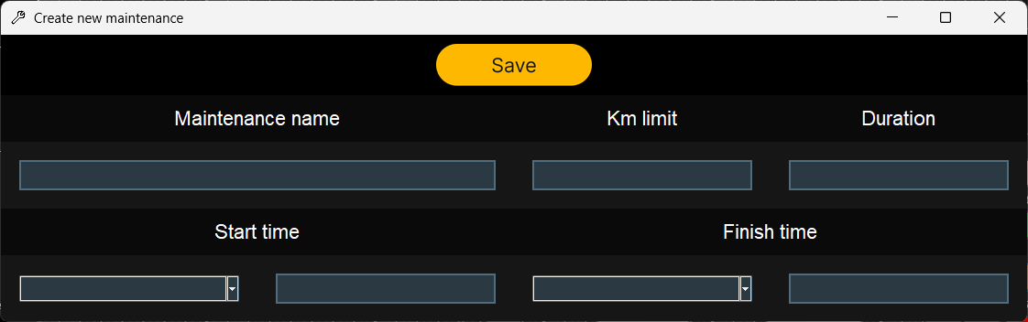
- A maintenance identifier, that will be displayed on top of the box.
- A mileage limit before which the maintenance activity must be performed.
- Duration, in hours, of the service. If departure and arrival times are specified, this field is completed automatically. Retroactively, if a pair of the previous fields is specified and this one, the unspecified one will be automatically filled.

Library menu

The library menu allows the user to create and save schedule elements, so they can be easily summoned later in a schedule with a few clicks. The library window is divided in three columns, one per type of schedule elements. All elements of the same type (services, maintenances or transfers) will be on a same column.
The creation/edition windows are very similar to the ones described in the Schedule Boxes subsection. There are a few new inputs in this case:
- Autolocation: If enabled, disables location selection menus. When a box is created, it will automatically select the origin and destiny values based on where it is painted, to make sure the new element matches its location with the existing elements at left and right.
- Autoduration: If enabled, disables duration, departure and arrival times. It also disables autopush to side. When the new element is drawn, it will automatically extend to left and right, until “hitting” an existing box.
- Autopush to side: If enabled, disables autoduration, departure and arrival times, but not duration as it is still needed. With this option marked, when a new box is drawn it will have a fixed duration but will be pushed in the chosen direction until hitting an existing element.
Also, the interaction with this window varies depending on where is it accessed from:
- If accessed from the main menu, both left and right clicking on an element will open its edition window.
- If accessed from a schedule, right clicking will allow to edit the properties of the different elements, while left clicking will enter the click-to-draw mode. In this mode, left clicking in the schedule will draw the desired element on the clicked row, and the clicked day.

